Outline:
This is a web application which is hosted on the Goldsmiths Linux virtual machine. It is titled the Health and fitness tracker, and it is built on Node.js, Express, EJS and MySQL. The application.
Once you access the application, it allows the user to register a new account or log in with an existing account. Once you are in, it allows the users to log workouts that they have completed and allows them to enter details like the workout done, how long it took to complete and the time it was done. Once this is done, there is another page for users to search for the workout routine they have completed, which searches a database that stores the workouts logged per user registered. All the data is stored on a MySQL database called Health. The application uses techniques taught in all the previous labs.
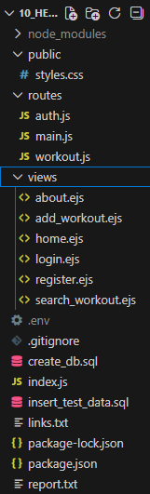

Architecture:
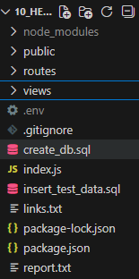

This is the main file layout, which shows everything is laid out. The greyed-out files are part of the .gitignore, as they cannot be pasted into GitHub. The second image shows the full layout within each folder. The application layer is index.js, the routes folder and the EJS views folder. The data tier includes MySQL database features with the health database. This database includes users and the workouts completed by each user. There is also the create database and insert data scripts inside the folder layout. Node.js + Express is used for routing and middleware. EJS is used for server-side rendering. Mysql2 is used for the database access.

Data model:
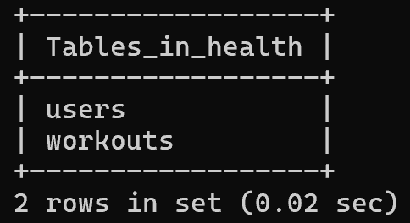
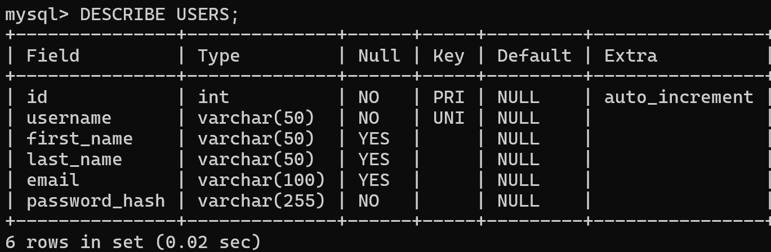
The screenshot above shows the two tables inside the health database.
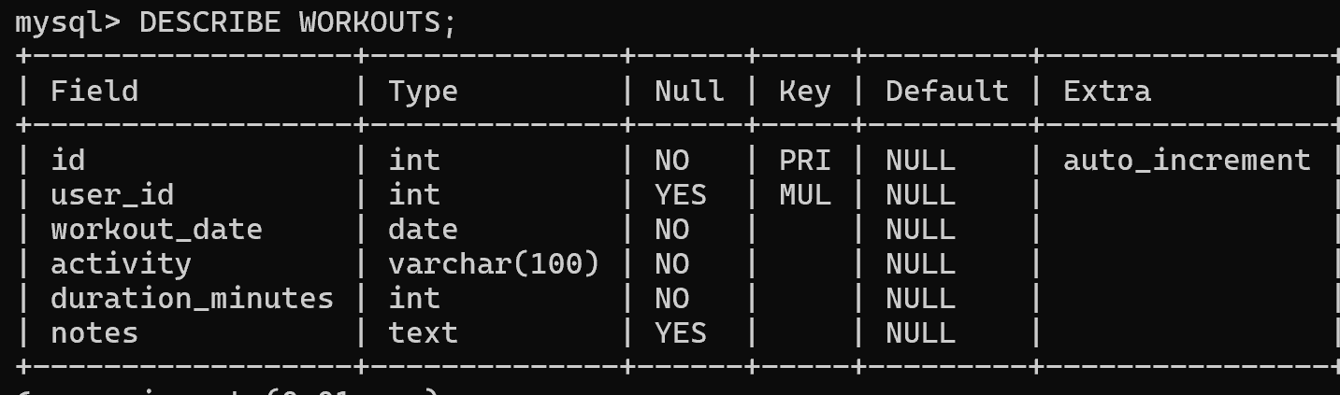
This screenshot shows the fields and data types inside the workouts table in the health database.

This screenshot shows the fields and data types inside the users table in the health database.

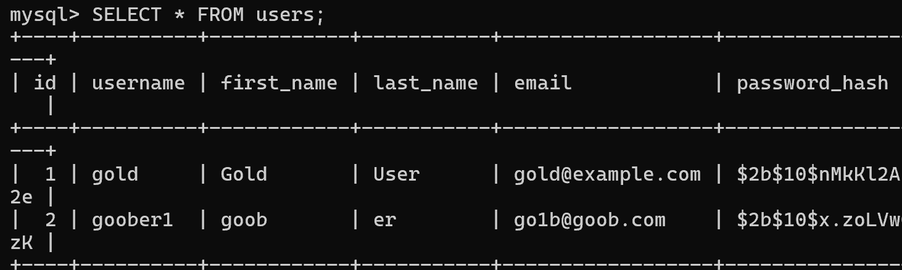

This screenshot shows the contents inside the user database right now.
This shows that there are 2 users with a first name, last name, email and a hashed password.

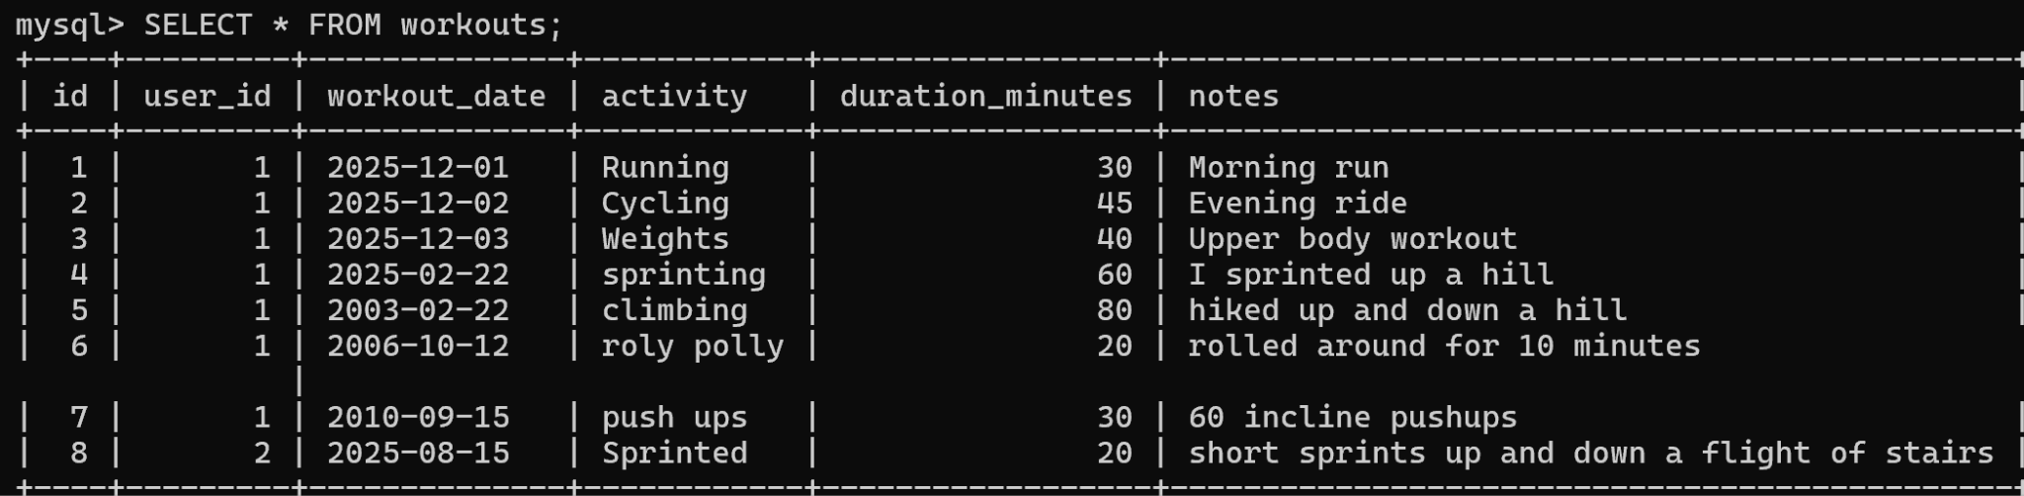

This screenshot shows the contents of the workout table. It shows the user ID for the account logged into. It shows the data registered for the workout, the activity listed by the user, the length of the activity and any notes related to what the activity was.

User functionality:
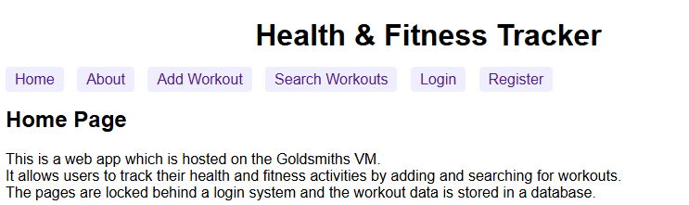

The website starts out the homepage. - This is the homepage loaded onto the vm.
This page holds the description of the website and has all the buttons available for each page on the website. There is a title for the app and there is the title based on what page you are currently on.

The main features include:
The main page - access to each other page. This page also confirms if the user is logged in or not and what account they are logged in as.
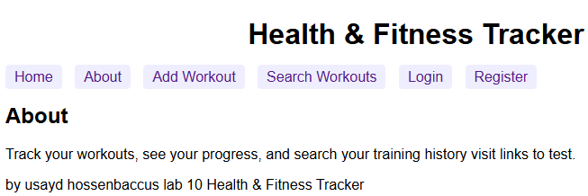
The about page does has the same functionality as the home page but begins to describe the features of the app and directs the user on where they can explore and what can be done.
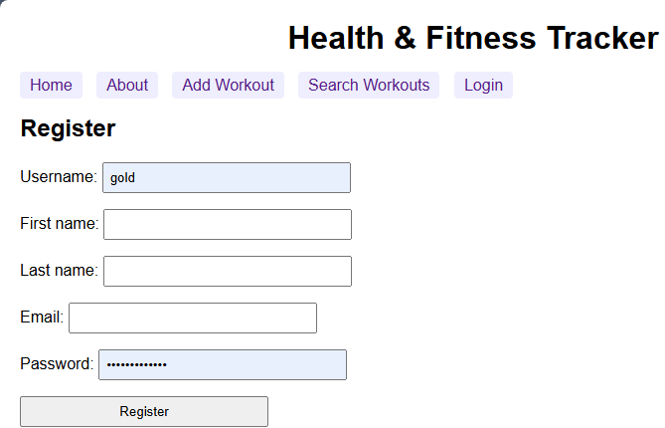

This is the registration page. It is a form format which allows the user to input their data in the fields as seen in screenshot above. The password is validated to ensure it contains at least 8 character length, lower and upper case letter and a number / special character. All the fields are validated and if none are filled out correctly the user will get a prompt to alert them of what has gone wrong. If the user successfully inputs their details it stores them in the database and allows the user to log in with those credentials in the future.

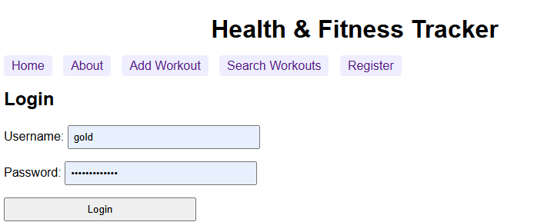
This is the log in page. It checks for the data stored in the database to see if there is credentials saved for the user to log in with. If the user cannot enter the correct details they are prompted to check what their credentials are before they log in again.
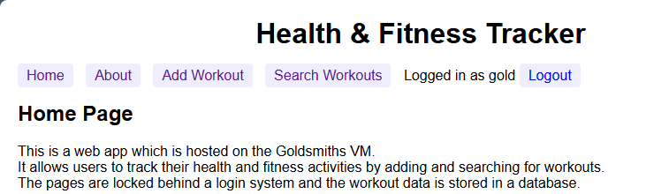
Once they are logged in you can see what user you are logged in as on the top right of the screen. There is also a button allowing the user to log out and re log in or register a new user. The log in page is set on the add workout tab and on the search workout tabs.

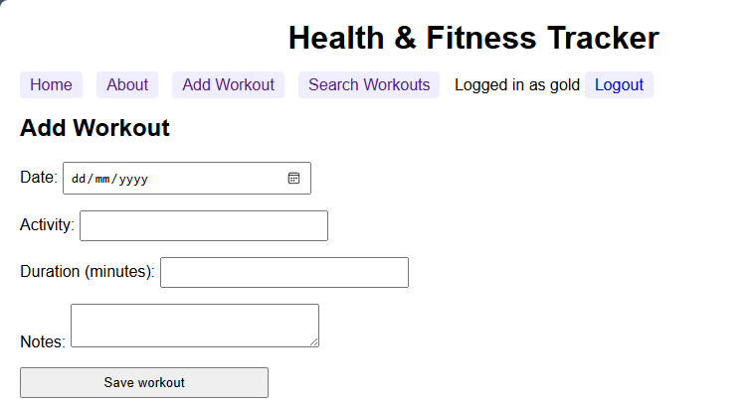

This page is another form format allowing the user to fill out all the fields. This page allows the user to input the time, activity, duration of exercise and the notes related to each exercise. Similar to the log in page if it is not filled out correctly the user is prompted with a message to complete the page correctly. Once the save workout button is pressed it saves the details the user listed into the data base saving it under their user and allowing them to search for the workout routine.

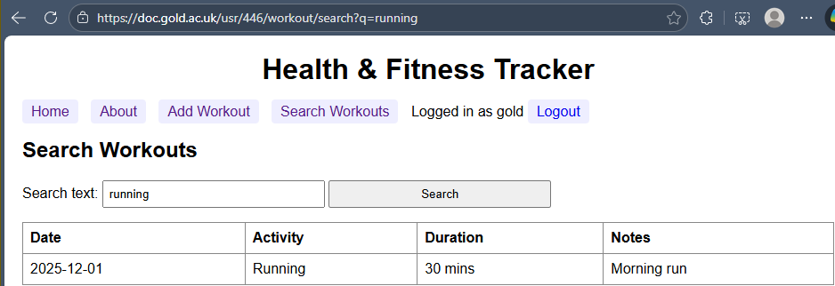
This is the search workout page. It displays the to the user any workouts they have saved with all the details displayed in a neat table format. This table includes all the fields in the add workout tab. If the user types in a workout which was not saved this pops up:
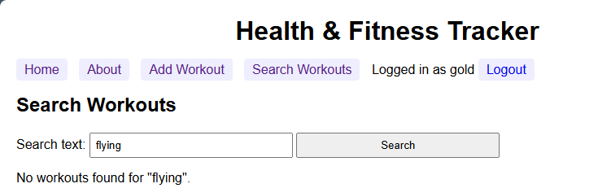

This page shows that the user has not added any workout that is related to what they typed into the box. The keywords the users type in match anything that can be found in the fields when the user submitted the workouts.
Advanced techniques:
One advanced technique I implemented was the use of hashing and the bcrypt library. After creating a hashing script i used the hashed password to put into the database for the user log in.

There is also session based authentication in my application. Environment variables are also utilised in this application. Database access is also a big feature.

AI declaration:
I used AI to clarify the syntax needed on the powershell and git commands.
I used AI to link the my sql application to my Vs powershell.
I used AI to understand apache and how that interacts with the code on the Vm.
I used AI to summarise possible linux syntax that could interact with my code.
I used AI to help understand the concepts in the work.
I used AI in configuration of the code like understanding .env and .gitignores and dependency installations.
I used AI to help learn the correct syntaxes and possibilities for minor applications in ejs
I used AI to help verify folder structure before pushing to git

